UNIT-I
MEANING OF ECONOMICS
The word ‘Economics’ originates from the Greek work ‘Oikonomikos’ which can be divided into two parts: (a) ‘Oikos’, which means ‘Home’, and (b) ‘Nomos’, which means ‘Management’. Thus, Economics means ‘Home Management’. The head of a family faces the problem of managing the unlimited wants of the family members within the limited income of the family. In fact, the same is true for a society also. If we consider the whole society as a ‘family’, then the society also faces the problem of tackling unlimited wants of the members of the society with the limited resources available in that society. Thus, Economics means the study of the way in which mankind organises itself to tackle the basic problems of scarcity. All societies have more wants than resources. Hence, a system must be devised to allocate these resources between competing ends.
DEFINITIONS OF ECONOMICS
We have now formed an idea about the meaning of Economics. This at once leads to a general definition of Economics. Economics is the social science that studies economic activities. This definition is, however, too broad. It does not specify the exact manner in which the economic activities are to be studied. Economic activities essentially mean production, exchange and consumption of goods and services. However, with the progress of civilisation, the complexity of the production, exchange and consumption processes in society have increased manifold. Economists at different times have emphasised different aspects of economic activities, and have arrived at different definitions of Economics. We shall now discuss some of these definitions in detail. These definitions can be classified into four groups:
1. Wealth definitions,
2. Material welfare definitions,
3. Scarcity definitions, and
4. Growth-centred definitions.
Adam Smith’s Definition
Adam Smith, considered to be the founding father of modern Economics, defined Economics as the study of the nature and causes of nations’ wealth or simply as the study of wealth. The central point in Smith’s definition is wealth creation. Implicitly, Smith identified wealth with welfare. He assumed that, the wealthier a nation becomes the happier are its citizens. Thus, it is important to find out, how a nation can be wealthy. Economics is the subject that tells us how to make a nation wealthy. Adam Smith’s definition is a wealth-centred definition of Economics.

Main Characteristics of Wealth Definitions
1. Exaggerated emphasis on wealth: These wealth centered definitions gave too much importance to the creation of wealth in an economy. The classical economists like Adam Smith, J.S. Mill, J.B. Say, and others believed that economic prosperity of any nation depends only on the accumulation of wealth.
2. Inquiry into the creation of wealth: These definitions show that Economics also deals with an inquiry into the causes behind the creation of wealth. For example, wealth of a nation may be increased through raising the level of production and export.
3. A study on the nature of wealth: These definitions have indicated that wealth of a nation includes only material goods (e.g., different manufactured items). Non-material goods were not included. Hence, non-material goods like services of teachers, doctors, engineers, etc., are not considered as ‘wealth’.
Alfred Marshall’s Definition
Alfred Marshall also stressed the importance of wealth. But he also emphasised the role of the individual in the creation and the use of wealth. He wrote: “Economics is a study of man in the ordinary business of life. It enquires how he gets his income and how he uses it. Thus, it is on the one side, the study of wealth and on the other and more important side, a part of the study of man”. Marshall, therefore, stressed the supreme importance of man in the economic system. Marshall’s definition is considered to be material-welfare centred definition of Economics
Features of Material Welfare Definitions The main features of material welfare-centred definitions are as follows:
1.Study of material requisites of well-being: These definitions indicate that Economics studies only the material aspects of well-being. Thus, these definitions emphasise the materialistic aspects of economic welfare.
2.Concentrates on the ordinary business of life: These definitions show that Economics deals with the study of man in the ordinary business of life. Thus, Economics enquires how an individual gets his income and how he uses it.
3.A stress on the role of man: These definitions stressed on the role of man in the creation of wealth or income
Lionel Robbins’ Definition
The next important definition of Economics was due to Prof. Lionel Robbins. In his book ‘Essays on the Nature and Significance of the Economic Science’, published in 1932, Robbins gave a definition which has become one of the most popular definitions of Economics. According to Robbins, “Economics is a science which studies human behaviour as a relationship between ends and scarce means which have alternative uses”. A long line of economists after Robbins, including Scitovsky and Cassel agreed with this definition and carried on their analysis in line with this definition. It is a scarcity-based definition of Economics.
Main Features of Scarcity Definition: The principal features of scarcity definitions are as follows:
1.Human wants are unlimited: The scarcity definition of Economics states that human wants are unlimited. If one want is satisfied, another want crops up. Thus, different wants appear one after another.
2.Limited means to satisfy human wants: Though wants are unlimited, yet the means for satisfying these wants are limited. The resources needed to satisfy these wants are limited. For example, the money income (per month) required for the satisfaction of wants of an individual is limited. Any resource is considered as scarce if its supply is less than its demand.
3.Alternative uses of scarce resources: Same resource can be devoted to alternative lines of production. Thus, same resource can be used for the satisfaction of different types of human wants. For example, a piece of land can be used for either cultivation, or building a dwelling place or building a factory shed, etc.
4.Efficient use of scarce resources: Since wants are unlimited, so these wants are to be ranked in order of priorities. On the basis of such priorities, the scarce resources are to be used in an efficient manner for the satisfaction of these wants.
5.Need for choice and optimisation: Since human wants are unlimited, so one has to choose between the most urgent and less urgent wants. Hence, Economics is also called a science of choice. So, scarce resources are to be used for the maximum satisfaction (i.e., optimisation) of the most urgent human wants.
Modern Growth-Oriented Definition of Samuelson
In relatively recent times, more comprehensive definitions of Economics have been offered. Thus, Professor Samuelson writes, “Economics is the study of how people and society end up choosing, with or without the use of money, to employ scarce productive resources that could have alternative uses to produce various commodities over time and distributing them for consumption, now or in the future, among various persons or groups in society. It analyses costs and benefits of improving patterns of resource allocation”. A large number of modern economists subscribe to this broad definition of Economics.
Features of the Modern Growth-Oriented Definition
- Growth-orientation: Economic growth is measured by the change in national output over time. The definition says that, Economics is concerned with determining the pattern of employment of scarce resources to produce commodities ‘over time’. Thus, the dynamic problems of production have been brought within the purview of Economics.
- Dynamic allocation of consumption: Similarly, under this definition, Economics is concerned with the pattern of consumption, not only now but also in the future. Thus, the problem of dividing the use of income between present consumption and future consumption has been brought within the orbit of Economics.
- Distribution: The modern definition also concerns itself with the distribution of consumption among various persons and groups in a society. Thus, while the problem of distribution is implicit in the earlier definitions, the modern definition makes it explicit.
- Improvement of resource allocation: The definition also says that, Economics analyses the costs and benefits of improving the pattern of resource allocation. Improvement of resource allocation and better distributive justice are synonymous with economic development. Thus, issues of development of a less developed economy have also been made subjects of the study of Economics.
BRANCHES OF ECONOMICS:
Economic theory, as it stands today, has several branches. Of these, two are most important. These are microeconomics and macroeconomics. We shall now briefly mention the major features of these two branches to have an idea regarding the nature of economics.
Microeconomics
Microeconomics is that branch of economics which is concerned with the decision-making of a single unit of an economic system. How does an individual (or a family) decide on how much of various commodities and services to consume? How does a business firm decide how much of its product (or products) to produce? These are the typical questions discussed in microeconomics. Determination of income, employment, etc. in the economic system as a whole is not the concern of microeconomics. Thus, microeconomics can be defined as the study of economic decision-making by micro-units.
Usefulness of Microeconomics
1. Determination of demand pattern: The study of microeconomics has several uses. It determines the pattern of demand in the economy, i.e., the amounts of the demand for the different goods and services in the economy, because the total demand for a good or service is the sum total of the demands of all the individuals. Thus, by determining the demand patterns of every individual or family, microeconomics determines the demand pattern in the country as a whole.
2. Determination of the pattern of supply: In a similar way, the pattern of supply in the country as a whole, can be obtained from the amounts of goods and services produced by the firms in the economy. Microeconomics, therefore, determines the pattern of supply as well.
3. Pricing: Probably the most important economic question is the one of price determination. The prices of the various goods and services determine the pattern of resource allocation in the economy. The prices, in turn, are determined by the interaction of the forces of demand and supply of the goods and services. By determining demand and supply, microeconomics helps us in understanding the process of price determination and, hence, the process of determination of resource allocation in a society.
4. Policies for improvement of resource allocation: As is well-known, economic development stresses the need for improving the pattern of resource allocation in the country. Development polices, therefore, can be formulated only if we understand how the pattern of resource allocation is determined. For instance, if we want to analyse how a tax or a subsidy will affect the use of the scarce resources in the economy, we have to know how these will affect their prices. By explaining prices and, hence, the pattern of resource allocation, microeconomics helps us to formulate appropriate development policies for an underdeveloped economy.
5. Solution to the problems of micro-units: Finally, it goes without saying that, since the study of microeconomics starts with the individual consumers and producers, policies for the correction of any wrong decisions at the micro-level are also facilitated by microeconomics. For example, if a firm has to know exactly what it should do in order to run efficiently, it has to know the optimal quantities of outputs produced and of inputs purchased. Only then can any deviation from these optimal levels be corrected. In this sense, microeconomics helps the formulation of policies at the micro-level. In every society, the economic problems faced by different economic agents (such as individual consumers, producers, etc.) can be analysed with the help of microeconomic theories. This shows that economics is a social science which aims at analysing the economic behaviour of individuals in a social environment.
MACROECONOMICS
Macroeconomics is that branch of economics which is concerned with the economic magnitudes relating to the economic system as a whole, rather than to the microeconomic units like individuals or firms. It has, therefore, been called ‘aggregative economics’. In the picturesque language of Kenneth Boulding, “Macroeconomics deals ... not with individual income but with national income, not with individual prices but with the price level, not with individual outputs but with national output”
Importance of Macroeconomics
Why is the study of macroeconomics important? To put it briefly, macroeconomics deals with some of the questions untouched by microeconomics. The study of economics is, therefore, left incomplete, if we do not study macroeconomics. Some of the important issues analysed in macroeconomics are the following:
1. Income and employment determination: The determination of national income and of total employment in the country are vital concerns of macroeconomics. Since the volume of unemployment is simply population minus the number of people employed, unemployment is determined as soon as the employment level is known.
2. Price level: The determination of the general price level is discussed in macroeconomic theories. Upward movement of the general price level is known as inflation. Thus, if we want to understand the process of inflation and find ways of controlling it, we must resort to the study of macroeconomics.
3. Business cycles: The economic booms and depressions in the levels of income and employment follow one another in a cyclical fashion. While income rises and employment expands during boom periods, they shrink during depressions. Since depressions bring business failures and unemployment in their wake, economists have sought remedies to depressions. Discussion of business cycles in general and anti-depression policies in particular, fall within the scope of macroeconomics.
4. Balance of payments: The balance of payments theory is also a part of macroeconomics. The difference between the total inflow and the total outflow of foreign exchange is known as the balance of payments of a country. When this balance is negative (i.e., outflow exceeds inflow), the country faces a lot of economic hardships. The causes and remedies of such balance of payments problems are discussed in macroeconomics.
5. Government policies: The effects of various government policies on the economic variables like national income or the general price level are also studied in macroeconomics. [It should be noted that, we are talking of the macroeconomic effects of government policies. The effects of these policies on the micro-units (for instance, the effects of taxes on the output of an individual firm), are the subject-matter of microeconomics.] Since, the Government occupies an important position in any modern economic system, the analysis of these effects is of obvious importance. 6. Interrelations between markets: Probably, the most important contribution of macroeconomic theories is to show that different markets of the economic system (for example, the commodity market, the labour market, the bond market, the money market, etc.) are interrelated. Any disturbance in one of these markets affects all the others. (Again, it should be noted that, it is the interrelation between the macroeconomic markets that we are talking here. The relationship between the markets of the individual commodities is the subjectmatter of ‘general equilibrium theory’, which is a part of microeconomics).
Thus, we see that the study of microeconomics and that of macroeconomics are complementary to each other. The limitations of microeconomics are covered by macroeconomics. On the other hand, macroeconomics does not make a detailed study of the individual consumer or producer. This is taken care of by microeconomics. One can hope to form a comprehensive notion of what economics is all about only when one is acquainted with both microeconomics and macroeconomics.

Law of Diminishing Marginal Utility

The law of diminishing marginal utility was first propounded by 19th century German economist H.H. Gossen which explains the behavior of the consumers and the basic tendency of human nature. Hence, this law is also known as Gossen’s First Law. This was further modified by Marshall.

According to Marshall, The additional benefit a person derives from a given increase of his stock of anything diminishes with the growth of the stock that he already has.
As per the definitions, we can conclude that, if the consumer consumes goods continuously, the utility obtained from every successive unit goes on diminishing. If the consumer is consuming the goods continuously, firstly he reaches the point of maximum satisfaction which is known as level of satiety. If he continues to consume the goods again, the utility obtained from that particular goods goes in negative aspect or he gets inutility.

Example to Demonstrate Law of Diminishing Marginal Utility
Unit of biscuits | Marginal utility | Total utility
1 | 6 | 6
2 | 4 | 10
3 | 2 | 12
4 | 0 | 12
5 | -2 | 10
6 | -4 | 6

The table shows that when a consumer consumes 1st unit of orange he derives the marginal utility equal to 6utils. As the consumer consumes 2nd and 3rd units of orange, the marginal utility is declined from 4utils to 2utils respectively. When he consumes 4th unit of orange the marginal utility becomes zero, which is called the point of satiety. Similarly, from the consumption of 5th and 6th units of orange, the marginal utility becomes negative, i.e., he gets disutility instead of utility from these units of consumption. Thus, the table shows that a consumer consumes more and more units of a commodity at a certain period of time, the marginal utility declines, becomes zero and even negative.
This law can be further explained with the help of a diagram:
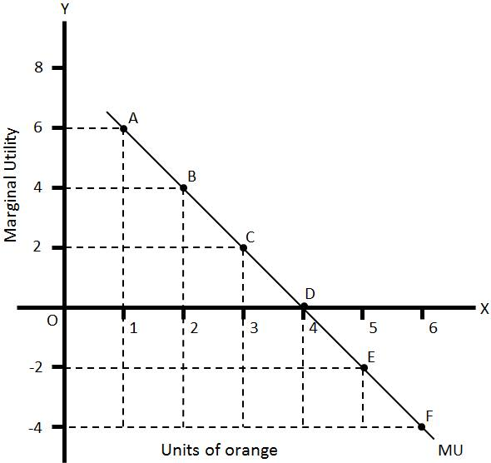
Law of Diminishing Marginal Utility Assumptions

i )The consumer who is consuming the goods should be logical and knowledgeable to consume every unit of goods.

ii) The goods which are to be consumed should be equal in size and shape.

iii) Consumer should consume the goods without time gap.

iv)The consumer’s income, preference, taste and fashion should not be changed while consuming the goods.

v) To hold the law good, utility should be measured in countable units.

Vi) As we know that money is the measuring rod of utility, being so, marginal utility of money should remain constant during consumption of the goods.

vii) All the units of the commodity should be identical and homogeneous in all respects like quality ,taste flavour etc.

Importance of the law
i) This law is useful to the government in the imposition of taxes. From this government knows that additional money earned by rich people gives lesser satisfaction that is why the government imposes high rates of tax on the income of the rich people and low rates of tax on income of the poor people.
ii) This law is the basis for many economic laws like law of demand, law of equi-marginal utility ect.
iii) This law is helpful to the producers in determining the price of a commodity.

Law of Equi- Marginal Utility
The law of equi marginal utility was presented in 19th century by an Australian economists H. H. Gossen. It is also known as law of maximum satisfaction or law of substitution or Gossen's second law. A consumer has number of wants. He tries to spend limited income on different things in such a way that marginal utility of all things is equal. When he buys several things with given money income he equalizes marginal utilities of all such things. The law of equi marginal utility is an extension of the law of diminishing marginal utility. The consumer can get maximum utility by allocating income among commodities in such a way that last rupee spent on each item provides the same marginal utility.

Definition:
"A person can get maximum utility with his given income when it is spent on different commodities in such a way that the marginal utility of money spent on each item is equal".
It is clear that consumer can get maximum utility from the expenditure of his limited income. He should purchase such amount of each commodity that the last unit of money spend on each item provides same marginal utility.

Assumptions of the Law of Equi Marginal Utility
- There is no change in the prices of the goods.
- The income of consumer is fixed.
- The marginal utility of money is constant.
- Consumer has perfect knowledge of utility obtained from goods.
- Consumer is normal person so he tries to seek maximum satisfaction.
- The utility is measurable in cardinal terms.
- Consumer has many wants.
- The goods have substitutes

Explanation with Schedule and Diagram:
The law of substitution can be explained with the help of an example. Suppose consumer has six dollars that he wants to spend on apples and bananas in order to obtain maximum total utility. The following table shows marginal utility (MU) of spending additional dollars of income on apples and bananas:
Money (Units) | MU of apples | MU of bananas
1 | 10 | 8
2 | 9 | 7
3 | 8 | 6
4 | 7 | 5
5 | 6 | 4
6 | 5 | 3

Total total utility for consumer is 49 utils that is the highest obtainable with expenditure of Rs 4 on apples and Rs 2 on bananas. Here the condition MU of apple = MU of banana i.e 7 = 7 is also satisfied. Any other allocation of the last rupee shall give less total utility to the consumer.

The same information can be used for graphical presentation of this law:

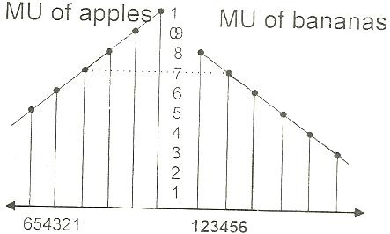

Limitations:
- The law is not applicable in case of knowledge. Reading of books provides more satisfaction and knowledge to the scholar. Different books provide variety of knowledge and satisfaction.
- The law is not applicable in case of indivisible goods. The consumer is unable to divide the goods to adjust units of utility derived from consumption of goods.
- There is no measurement of utility. It is psychological concept. It is not possible to express it into quantitative form.
- The law does not hold well in case fashion and customs. The people like to spend money on birthdays, marriages and deaths.
- The does not hold well in case of very low income. The maximization of utility is not possible due to low income.
- The law is not applicable in case of durable goods. The calculation of marginal utility of durable goods is impossible.
- The law fails when goods of choice are not available. The consumer is bound to use commodity, which provides low utility due to non availability of goods having high utility.
- There are certain lazy consumers. They do not care for maximum utility. The law fails to operate in case of laziness of consumers. They go on consuming goods with comparing utility.
- It does not work when there are frequent prices changes. The consumer is unable to calculate utility of different commodities. Changing price levels create confusion in the minds of consumers.
- There may be unlimited resources. The does not work due to unlimited resources. There is no need to change the direction of expenditure from one item to another when there are gifts of nature.

Importance:
- The law of equi marginal utility is helpful in the field of production. The producer has limited resources. He uses limited resources to purchase production factors. He tries to equalize marginal utility of all factors. He wishes to get maximum output and profit.
- National income is distributed among factors of production according to this law. An entrepreneur can pay factors of production equal to marginal product measured in money terms. He will substitute one factor for another until marginal productivity of all factors is equal to prices of their services.
- The law is used in the field of exchange. The people like to exchange a commodity having low utility with a commodity having high utility. There is maximum benefit from exchange of commodities. The law is helpful in exchange of wealth, trade, import and export.
- The law is applicable in consumption. A rational consumer tries to get maximum satisfaction when he spends his limited resources on various things. He tries to equalize weighted marginal utility of all the things.
- The law is applicable in public finance. The government can spend its revenue to get maximum social advantage. The marginal utility of each dollar spent in one sector must be equal to marginal utility derived from all other sectors.
- The law is useful for workers in allocating the time between work and rest. They can compare the marginal utility of work and the marginal utility of rest. They can decide working hours and rest hours.
- The law holds well in case of saving and spending. The consumer can make choice between present wants and future wants. He can feel that a rupee saved has greater utility than a rupee spent, he can save more and spend less. He will substitute saving and spending till marginal utility of a dollar spent and a dollar saved are equal.
- The law is helpful in prices. Due to scarcity of commodity its prices go up. The law tells us to use substitute commodity, which is less scarce. The result is that the price of commodity comes down.

Introduction to demand and supply: The concepts of demand and supply are useful for explaining what is happening in the market place. Every market transaction involves an exchange and many exchanges are undertaken in a single day. The circular flow of economic activity explains clearly that every day there are a number of exchanges taking place among the four major sectors mentioned earlier.
A market is a place where we buy and sell goods and services. A buyer demands goods and services from the market and the sellers supply the goods in the market. In economics, demand is “the quantity of goods and services that will be bought for a given price over a period of time”. For example if 10 Lakhs laptops are purchased in India during a year at an average price of Rs.25000/- then we can say that the annual demand for laptops is 10 Lakhs units at the rate of 25,000/-.
This chapter describes demand and supply which is the driving force behind a market economy. This is one of the most important managerial factors because it assists the managers in predicting changes in production and input prices. The manager can take better decisions regarding the kind of product to be produced, the quantity, the cost of the product and its selling price. Let us understand the concept of demand and its importance in decision making. Demand: Demand means the ability and willingness to buy a specific quantity of a commodity at the prevailing price in a given period of time. Therefore, demand for a commodity implies the desire to acquire it, willingness and the ability to pay for it.
Demand function is a function that describe how much of a commodity will be purchased at the prevailing prices of that commodity and related commodities, alternative income levels, and alternative values of other variables affecting demand.
Price is not the only factor which determines the level of demand for a good. Other important factor is income. The rise in income will lead to an increase in demand for a normal commodity. A few goods are named as inferior goods for which the demand will fall, when income rises. Another important factor which influences the demand for a good is the price of other goods. Other factors which affect the demand for a good apart from the above mentioned factors are: Changes in Population Changes in Fashion Changes in Taste Changes in Advertising A change in demand occurs when one or more of the determinants of demand change and it is expressed in the following equation. Qd X = f (Px , Pr , Y, T, Ey , Ep , Adv….)
Where, Qd X = quantity demanded of good ‘X
’ Px = the price of good X
Pr = the price of a related good
Y = income level of the consumer
T = taste and preference of the consumers
E y = expected income
E p = expected price
Adv = advertisement cost
The above mentioned demand function expresses the relationship between the demand and other factors. The quantity demanded of commodity X varies according to the price of commodity (Px ), income (Y), the price of a related commodity (Pr ), taste and preference of the consumers (T), expected income (Ey ) and advertisement cost(Adv) spent by the organization.
Determinants Of Demand: There are various factors affecting the demand for a commodity. They are:
1.Price of the good: The price of a commodity is an important determinant of demand. Price and demand are inversely related. Higher the price less is the demand and vice versa.
2.Price of related goods: The price of related goods like substitutes and complementary goods also affect the demand. In the case of substitutes, rise in price of one commodity lead to increase in demand for its substitute. In the case of complementary goods, fall in the price of one commodity lead to rise in demand for both the goods.
3.Consumer’s Income: This is directly related to demand. A change in the income of the consumer significantly influences his demand for most commodities. If the disposable income increases, demand will be more.
4.Taste, preference, fashions and habits: These are very effective factors affecting demand for a commodity. When there is a change in taste, habits or preferences of the consumer, his demand will change. Fashions and customs in society determine many of our demands.
5.Population: If the size of the population is more, demand for goods will be more . The market demand for a commodity substantially changes when there is change in the total population.
6.Money Circulation: More the money in circulation, higher the demand and vice versa.
7.Value of money: The value of money determines the demand for a commodity in the market. When there is a rise or fall in the value of money there may be changes in the relative prices of different goods and their demand.
8.Weather Condition: Weather is also an important factor that determines the demand for certain goods.
9.Advertisement and Salesmanship: If the advertisement is very attractive for a commodity, demand will be more. Similarly if the salesmanship and publicity is effective then the demand for the commodity will be more.
10.Consumer’s future price expectation: If the consumers expect that there will be a rise in prices in future, he may buy more at the present price and so his demand increases.
11.Government policy (taxation): High taxes will increase the price and reduce demand, while low taxes will reduce the price and extend the demand.
12.Credit facilities: Depending on the availability of credit facilities the demand for commodities will change. More the facilities higher the demand.
13.Multiplicity of uses of goods: if the commodity has multiple uses then the demand will be more than if the commodity is used for a single purpose.
Demand Distinctions: Types of Demand
Demand may be defined as the quantity of goods or services desired by an individual, backed by the ability and willingness to pay.
Types of Demand:
1. Direct and indirect demand: (or) Producers’ goods and consumers’ goods: demand for goods that are directly used for consumption by the ultimate consumer is known as direct demand (example: Demand for T shirts). On the other hand demand for goods that are used by producers for producing goods and services. (example: Demand for cotton by a textile mill)
2. Derived demand and autonomous demand: when a produce derives its usage from the use of some primary product it is known as derived demand. (example: demand for tyres derived from demand for car) Autonomous demand is the demand for a product that can be independently used. (example: demand for a washing machine)
3. Durable and non durable goods demand: durable goods are those that can be used more than once, over a period of time (example: Microwave oven) Non durable goods can be used only once (example: Band-aid)
4. Firm and industry demand: firm demand is the demand for the product of a particular firm. (example: Dove soap) The demand for the product of a particular industry is industry demand (example: demand for steel in India )
5. Total market and market segment demand: a particular segment of the markets demand is called as segment demand (example: demand for laptops by engineering students) the sum total of the demand for laptops by various segments in India is the total market demand. (example: demand for laptops in India)
6. Short run and long run demand: short run demand refers to demand with its immediate reaction to price changes and income fluctuations. Long run demand is that which will ultimately exist as a result of the changes in pricing, promotion or product improvement after market adjustment with sufficient time.
7.Joint demand and Composite demand: when two goods are demanded in conjunction with one another at the same time to satisfy a single want, it is called as joint or complementary demand. (example: demand for petrol and two wheelers) A composite demand is one in which a good is wanted for several different uses. ( example: demand for iron rods for various purposes)
8.Price Demand: The ability and willingness to buy specific quantities of a good at the prevailing price in a given time period.
9.Income Demand: The ability and willingness to buy a commodity at the available income in a given period of time.

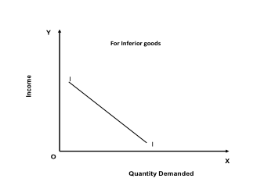

10.Cross Demand: The ability and willingness to buy a commodity or service at the prevailing price of the related commodity i.e. substitutes or complementary products. For example, people buy more of wheat when the price of rice increases

Law of demand: The quantity of a commodity demanded in a given time period increases as its price falls, ceteris paribus. (I.e. other things remaining constant)
Demand schedule: a table showing the quantities of a good that a consumer is willing and able to buy at the prevailing price in a given time period. (Table – 1)
Table – 1: The Demand Schedule For Coke
Price of Coke (200 ml) In Rupees | Quantity Demanded
50 | 1
45 | 2
40 | 3
35 | 5
30 | 7
25 | 9
20 | 12
15 | 15
10 | 20

Demand Curve:
A curve indicating the total quantity of a product that all consumers are willing and able to purchase at the prevailing price level, holding the prices of related goods, income and other variables as constant.

A demand curve is a graphical representation of a demand schedule. The price is quoted in the ‘Y’ axis and the quantity demanded over time at different price levels is quoted in ‘X’ axis. Each point on the curve refers to a specific quantity that will be demanded at a given price. If for example the price of a 200 ml coke is Rs. 10, this curve tells us that the consumer (the students in a class of 50) would purchase 20 units. When the price rises to Rs. 50 there was only one student would buy it. The demand curve, (DD) is downward sloping curve from left to right showing that as price falls, quantity demanded rises. This inverse relationship between price and quantity is called as the law of demand. When price changes, there is said to be a movement along the curve from point A to B.

Graph – Demand Curve

Exceptions or limitations to the law of demand: The law of demand does not apply in every case and situation. The circumstances when the law of demand becomes ineffective are known as exceptions of the law. Some of these important exceptions are as under.
1. Giffen Goods: Some special varieties of inferior goods are termed as Giffen goods. Cheaper varieties millets like bajra, cheaper vegetables like potato etc come under this category. Sir Robert Giffen of Ireland first observed that people used to spend more of their income on inferior goods like potato and less of their income on meat. After purchasing potato the staple food, they did not have staple food potato surplus to buy meat. So the rise in price of potato compelled people to buy more potato and thus raised the demand for potato. This is against the law of demand. This is also known as Giffen paradox.
2. Conspicuous Consumption / Veblen Effect: This exception to the law of demand is associated with the doctrine propounded by Thorsten Veblen. A few goods like diamonds etc are purchased by the rich and wealthy sections of society. The prices of these goods are so high that they are beyond the reach of the common man. The higher the price of the diamond, the higher its prestige value. So when price of these goods falls, the consumers think that the prestige value of these goods comes down. So quantity demanded of these goods falls with fall in their price. So the law of demand does not hold good here.
3. Conspicuous Necessities: Certain things become the necessities of modern life. So we have to purchase them despite their high price. The demand for T.V. sets, automobiles and refrigerators etc. has not gone down in spite of the increase in their price. These things have become the symbol of status. So they are purchased despite their rising price.
4. Emergencies: During emergencies like war, famine etc, households behave in an abnormal way. Households accentuate scarcities and induce further price rise by making increased purchases even at higher prices because of the apprehension that they may not be available. . On the other hand during depression, , fall in prices is not a sufficient condition for consumers to demand more if they are needed.
5. Future Changes In Prices: Households also act as speculators. When the prices are rising households tend to purchase large quantities of the commodity out of the apprehension that prices may still go up. When prices are expected to fall further, they wait to buy goods in future at still lower prices. So quantity demanded falls when prices are falling.
6. Change In Fashion: A change in fashion and tastes affects the market for a commodity. When a digital camera replaces a normal manual camera, no amount of reduction in the price of the latter is sufficient to clear the stocks. Digital cameras on the other hand, will have more customers even though its price may be going up. The law of demand becomes ineffective.
7. Speculative Goods/ Outdated Goods/ Seasonal Goods: Speculative goods such as shares do not follow the law of demand. Whenever the prices rise, the traders expect the prices to rise further so they buy more. Goods that go out of use due to advancement in the underlying technology are called outdated goods. The demand for such goods does not rise even with fall in prices
8. Goods In Short Supply: Goods that are available in limited quantity or whose future availability is uncertain also violate the law of demand.
Elasticity Of Demand

In economics, the term elasticity means a proportionate (percentage) change in one variable relative to a proportionate (percentage) change inanother variable. The quantity demanded of a good is affected by changes in the price of the good, changes in price of other goods, changes in income and changes in other factors. Elasticity is a measure of just how much of
the quantity demanded will be affected due to a change in price or income.

Elasticity of Demand is a technical term used by economists to describe the degree of responsiveness of the demand for a commodity due to a fall in its price. A fall in price leads to an increase in quantity demanded and vice versa.

The elasticity of demand may be as follows:

i) Price Elasticity
ii) Income Elasticity and
iii) Cross Elasticity
iv) Advertising Elasticity

Price Elasticity

The response of the consumers to a change in the price of acommodity is measured by the price elasticity of the commodity demand.The responsiveness of changes in quantity demanded due to changes in price is referred to as price elasticity of demand. The price elasticity of demand is measured by dividing the percentage change in quantity demanded by the percentage change in price.

Price Elasticity = Proportionate change in the Quantity Demanded /
Proportionate change in price

OR

Price Elasticity = percentage change in quantity demanded/percentage change in price
ΔQ / Q
= -----------
ΔP / P

ΔQ = change in quantity demanded
ΔP = change in price
P = price
Q = quantity demanded

For example:
Quantity demanded is 20 units at a price of Rs.500. When there is a fall in price to Rs. 400 it results in a rise in demand to 32 units. Therefore the change in quantity demanded is12 units resulting from the change in price of Rs.100.

The Price Elasticity of Demand is = 500 / 20 x 12/100 = 3

The Determinants of Price Elasticity Of Demand

The elasticity of demand depends on the following factors:

1. Nature of the commodity: The demand for necessities is inelastic because the demand does not change much with a change in price. But the demand for luxuries is elastic in nature.

2. Extent of use: A commodity having a variety of uses has a comparatively elastic demand.

3. Range of substitutes: The commodity which has more number of substitutes has relatively elastic demand. A commodity with fewer substitutes has relatively inelastic demand.

4. Income level: People with high incomes are less affected by price changes than people with low incomes.

5. Proportion of income spent on the commodity: When a small part of income is spent on the commodity, the price change does not affect the demand therefore the demand is inelastic in nature. Example: match box
6. Urgency of demand / postponement of purchase: The demand for certain commodities are highly inelastic because you cannot postpone its purchase. For example medicines for any sickness should be purchased and consumed immediately.

7. Durability of a commodity: If the commodity is durable then it is used it for a long period. Therefore elasticity of demand is high. Price changes highly influences the demand for durables in the market.

8. Purchase frequency of a product/ recurrence of demand: The demand for frequently purchased goods are highly elastic than rarely purchased goods.

9. Time: In the short run demand will be less eastic but in the long run the demand for commodities are more elastic.

Types of Price Elasticity of Demand

The following are the possible combination of changes in Price and Quantity demanded. The slope of each combination is depicted in the following graphs.

1.Relatively Elastic Demand (Ed >1) a small percentage change in price leading to a larger change in Quantity demanded.

2.Perfectly Elastic Demand (Ed = ∞) a small change in price will change the quantity demanded by an infinite amount.
3.Relatively Inelastic Demand (Ed < 1) a change in price leads to a smaller percentage change in quantity demanded.

4.Perfectly Inelastic Demand (Ed = 0) the quantity demanded does not change regardless of the percentage change in price.

5.Unit Elasticity of Demand (Ed =1) the percentage change in quantity demanded is the same as the percentage change in price that caused it.

Income Elasticity
Income elasticity of demand measures the responsiveness of quantity demanded to a change in income. It is measured by dividing the percentage change in quantity demanded by the percentage change in income. If the demand for a commodity increases by 20% when income
increases by 10% then the income elasticity of that commodity is said to be positive and relatively high. If the demand for food were unchanged whenincome increases, the income elasticity would be zero. A fall in demand for a commodity when income rises results in a negative income elasticity of demand.
The following are the various types of income elasticity:
i) Zero Income Elasticity: The increase in income of the individual does not make any difference in the demand for that commodity. ( Ei = 0)

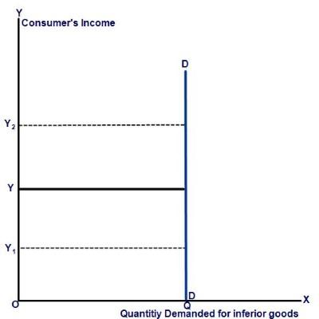
ii)Negative Income Elasticity: The increase in the income of consumers leads to less purchase of those goods. ( Ei < 0).

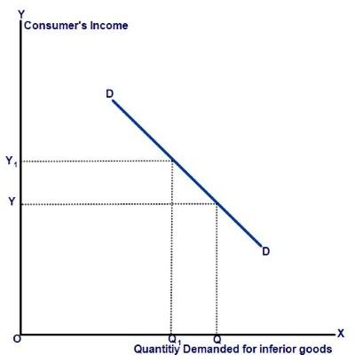

iii)Unitary Income Elasticity: The change in income leads to the same percentage of change in the demand for the good. ( Ei = 1).

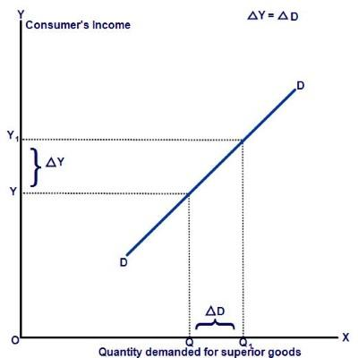

iv)Income Elasticity is Greater than 1: The change in income increases the demand for that commodity more than the change in the income. ( Ei > 1).
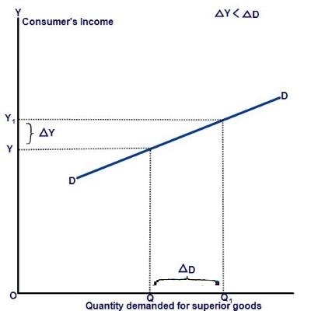

v)Income Elasticity is Less than 1: The change in income increases the demand for the commodity but at a lesser percentage than the change in the Income. ( Ei < 1).
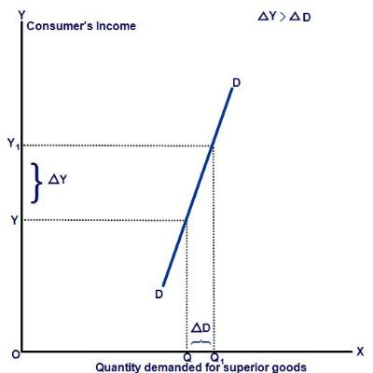

Cross Elasticity

The quantity demanded of a particular commodity varies according to the price of other commodities. Cross elasticity measures the responsiveness of the quantity demanded of a commodity due to changes in the price of another commodity. For example the demand for tea increases when the price of coffee goes up. Here the cross elasticity of demand for tea is high. If two goods are substitutes then they will have a positive cross elasticity of demand. In other words if two goods are complementary to each other then negative income elasticity may arise.
The responsiveness of the quantity of one commodity demanded to a change in the price of another good is calculated with the following formula.

% change in demand for commodity A
Ec = ------------------------------------------------
% change in price of commodity B

If two commodities are unrelated goods, the increase in the price of one good does not result in any change in the demand for the other goods. For example the price fall in Tata salt does not make any change in the demand for Tata Nano.

Advertising Elasticity of Demand
Advertising elasticity of demand measures the responsiveness of quantity demanded to a change in advertising expenditure

Advertising Elasticity = Proportionate change in the Quantity Demanded /
Proportionate change in advertising expenditure

Significance Of Elasticity Of Demand:

The concept of elasticity is useful for the managers for the following decision making activities
1. In production i.e. in deciding the quantity of goods to be produced

2. Price fixation i.e. in fixing the prices not only on the cost basis but also on the basis of prices of related goods.

3. In distribution i.e. to decide as to where, when, and how much etc.

4. In international trade i.e. what to export, where to export

5. In foreign exchange

6. For nationalizing an industry

7. In public finance

